Posted 09/06/2012 at 10:38 am by JAV

Town Hall Building Committee

DRAFT Agenda
Town Hall Meeting Room
Tuesday, September 11, 2012
7:00 PM

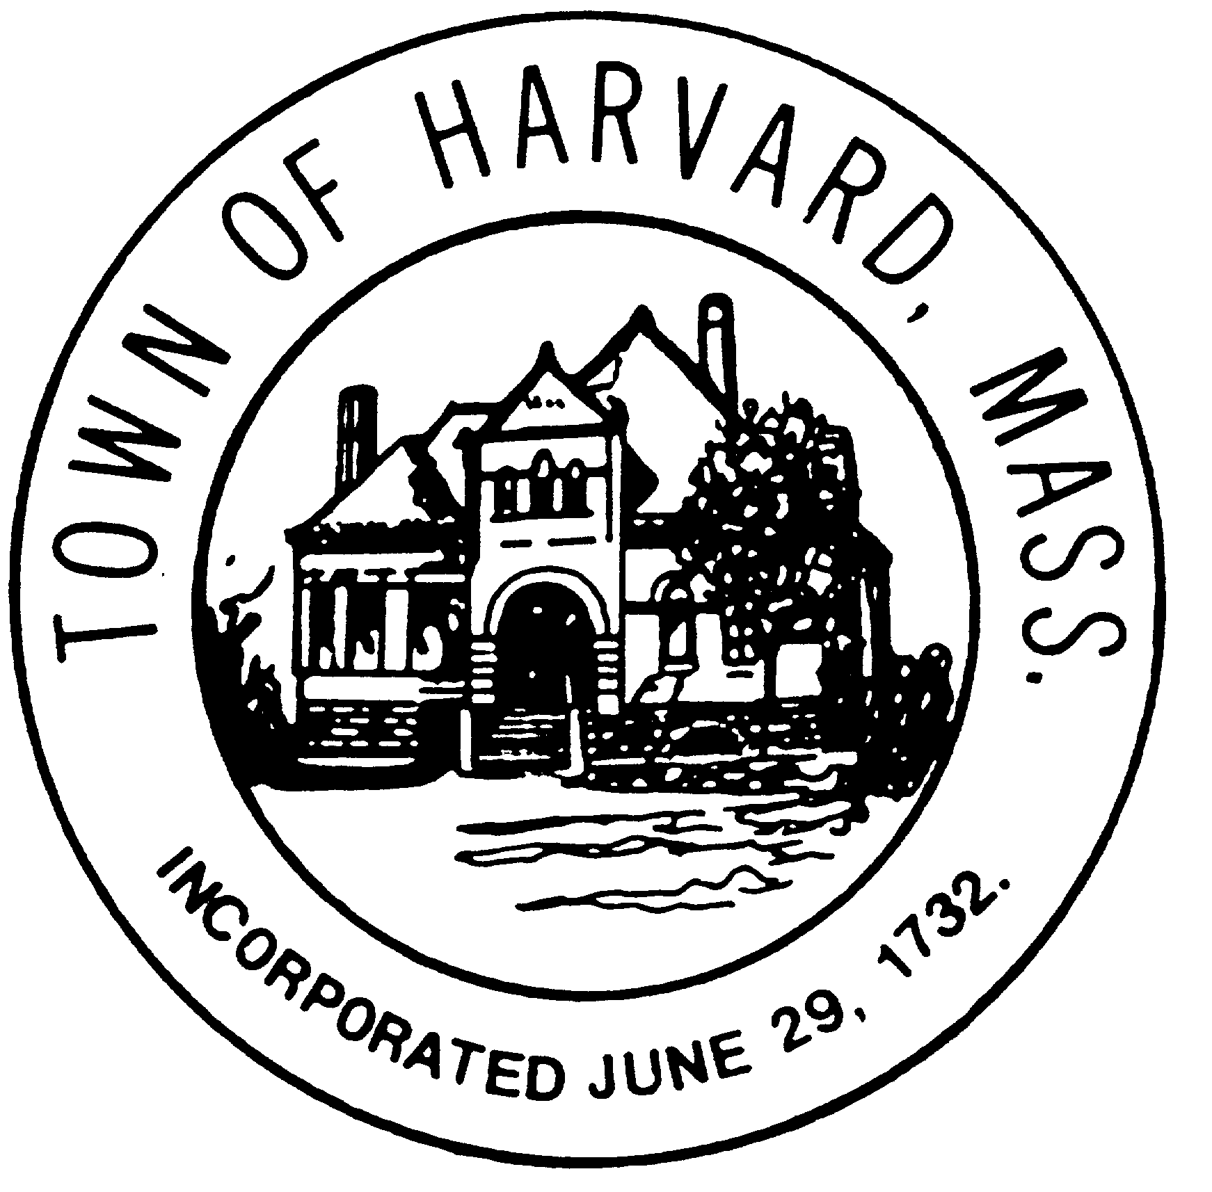
- Approve minutes

- Approve invoices

- Variance Discussion

- Update on DTI and LLB agreements

- Agenda and date for next meeting(s)

- New business

